**Role of Generalists in Reconciling Dissimilarity within Inventor Teams**

Innovation is important in firms’ success.

Team composition can affect innovative performance of the firm. Knowledge workers with different individual characteristics and background knowledge can contribute to the team’s performance differently.

Literature focuses on team diversity, team knowledge scope, etc. Studies show team member dissimilarity influences innovative performance. However, there are mixed effects of team member dissimilarity. Team diversity can both facilitate knowledge combination, and hinder cooperation at the same time. What is the effects contingent on? In this paper, I examine the role of generalist inventors in R&D teams. Generalist inventors can help facilitate knowledge recombination and enhance teamwork, mitigating problems that arise in teams with high levels of member diversity.

**Literature Review**

* diversified inventors are better at exploration (Nagle & Teodoridis, 2019)
* Firms with more specialized inventors create narrower scope technologies (Toh, 2014)
* Presence of generalist inventor in a team affects the economic relevance of innovation, contingent on level of domain uncertainty (Melero & Palomeras, 2015)
* The breadth and depth of expertise can influence innovation (Boh, Evaristo & Ouderkirk, 2014)
* Dissimilarity between team inventors have an inverted U-shaped effect on the impact of invention (Huo, Motohashi & Gong, 2019)

**Hypothesis**

presence of generalist inventors in a team will have a positive effect on the patent’s impact.

* Generalists will be better at exploring new domains and recognizing technological opportunities that arise.
* Generalists will be better at seeing the ‘bigger picture’, and facilitate efficient knowledge recombination
* Generalists will enhance teamwork by mitigating communication, conflict, and free-rider problems that may arise from knowledge variety.

H1. The average technological distance within an inventor team responsible for a patent will have an inverted U-shaped effect on the impact of the focal patent. (From previous literature)

H2. The proportion of generalist inventors in an inventor team responsible for a patent will positively moderate the effect of average technological distance within the team on the impact of the focal patent. (Main hypothesis)

**Preliminary Analysis**

* 4765 patents from top 10 biopharmaceutical firms from year 2010 to 2015 with 3 or more inventors
* Performed negative binomial regression with number of forward citations as dependent variable

Independent Variables

* Mean distance (computed as average of 1 – cosine similarity for all inventor dyads within a team) and its quadratic term
* Proportion of generalists in a team

I computed the Herfindahl–Hirschman Index (HHI) for the patent portfolio of each inventor. High HHI would mean the inventor’s portfolio is concentrated in few domains, and low HHI would indicate a more dispersed portfolio. For the preliminary analysis, I defined generalist inventors as inventors with HHI of 0.2 or lower. Among 20,275 unique inventors in the sample, 1,510 inventors (7.45%) were generalists.

* Interaction term between the mean distance and the proportion of generalists

Control Variables

Team size, Firm, Year, Team Scope (number of unique classes any inventor in the team has patented in), Patenting experience (sum of number of patents for any inventor in the team)

**Results**

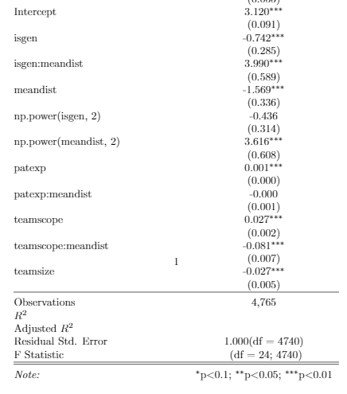

**H2**

**H1**

**H1**

* H1 is not supported. The regression shows the opposite effect form what is predicted.
* H2 is supported.